CCT College Dublin

Assessment Cover Page

Module Title: | Advanced Data Analysis  Big Data Storage and Processing
Assessment Title: | Comprehensive Data Analysis Pipeline with PySpark, Dash, Databases, Sentiment and Time Series Analysis on Tweets
Lecturer Name: | David McQuaid and Dr. Muhammad Iqbal
Student Full Name: | Kagan Timur
Student Number: | 2023044
Assessment Due Date: | 17.11.2023
Date of Submission: | 13.11.2023

Declaration

By submitting this assessment, I confirm that I have read the CCT policy on Academic Misconduct and understand the implications of submitting work that is not my own or does not appropriately reference material taken from a third party or other source. I declare it to be my own work and that all material from third parties has been appropriately referenced. I further confirm that this work has not previously been submitted for assessment by myself or someone else in CCT College Dublin or any other higher education institution.

Comprehensive Data Analysis Pipeline with PySpark, Dash, Plotly, Sentiment and Time Series Analysis on Tweets

Kagan Timur
CCT College Dublin
Dublin, Ireland
2023044@student.cct.ie

Abstract

This paper presents a novel framework that makes use of state-of-the-art big data technologies and sophisticated analytical techniques to analyze attitudes in Twitter data in a nuanced manner. The steps in the procedural continuum include careful data preprocessing, sentiment analysis, and visualization, all of which are coordinated by skillfully utilizing the PySpark, NLTK, and Dash libraries. Preprocessing is defined by strict temporal aspect standardization, thorough text cleaning, and normalizing via lowercase conversion. The VADER sentiment intensity analyzer is used to do sentiment analysis, a crucial step in the workflow. Sentiment evolution is discerned with granularity because to the daily temporal aggregation of the resulting sentiment scores. To fill in the gaps in the sentiment data, the framework uses skillful interpolation techniques, which strengthens the analytical resilience.

In order to address the issues raised by non-stationarity, a thorough time series analysis is carried out, utilizing the Kwiatkowski-Phillips-Schmidt-Shin (KPSS) and Augmented Dickey Fuller (ADF) tests. Furthermore, the framework incorporates machine learning models, such as Auto Regressive and Seasonal Autoregressive Integrated Moving Average (SARIMA) and Random Forest, to accurately predict future sentiment patterns. A follow-up study investigates how well the framework integrates with relational databases—more precisely, MySQL and Hive—using the Yahoo Cloud Serving Benchmark (YCSB) and cProfile to assess performance. The result of their efforts is a flexible and potent solution for sentiment analysis on large-scale social media datasets, providing detailed insights into temporal sentiment dynamics and making a significant contribution to the field's ongoing evolution.

Introduction

This project has direct application in real-world scenarios as it involves time series forecasting using dynamic dashboards and the analysis of a sizable dataset obtained from Twitter. Many businesses can benefit from the acquired abilities, which include large data management and processing, distributed systems design, advanced data analysis, and natural language processing. Social media marketing, brand reputation management, and financial market analysis are just a few of the industries that benefit from the capacity to foresee sentiment changes over time and extract insights from temporal data. The project's relevance to modern data analytics practices is further demonstrated by the emphasis on using distributed data processing environments, comparing database performance, and developing dynamic dashboards.

This dataset is contained in a CSV file and includes unique characteristics for every tweet, such as identifiers ('ids'), time information indicating the tweet's date, a binary indicator ('flag') indicating whether or not a query is attached to the tweet, the user who posted the tweet, and the tweet's text. Owing to the dataset's enormous size, a prudent choice was made to store it on the Hadoop Distributed File System (HDFS), which runs on Linux. The analytical activities are carefully coordinated by means of the PySpark API from Apache Spark, which is easily connected with the Python programming language. This technological stack selection places the project into an environment that supports scalable and effective data processing and analysis. It is based on the ideas of distributed computing and makes use of Hadoop and Spark's capabilities.

PySpark facilitates a thorough pre-processing and preparation regimen for the DataFrame. The first step is to carefully modify each column's data type so that it exactly matches the analytical requirements. Simultaneously, column names are selectively highlighted to improve further detailed examination. A thorough search for null values is done, and the results show that there are no abnormalities of this kind. The content is put through a stringent cleaning procedure that uses regular expressions to remove special symbols and lowercases all letters to enforce consistency.

Sentiment analysis using the Vader Sentiment Analysis approach is a crucial component of the analysis. Tokenization, lemmatization, and stopword elimination are among the Natural Language Processing (NLP) procedures that come after this initial analysis. A strategic choice to continue with the study without using these NLP techniques is made in response to noticeably low sentiment scores after applying them. The subsequent outcomes are shown in detail via an advanced web dashboard powered by Dash.

When zero emotion scores are found in particular rows, a thorough investigation of interpolation techniques is conducted, and linear interpolation is ultimately chosen for additional examination. The dashboard's results are also smoothly incorporated into the Auto Regressive and Seasonal Auto Regressive Integrated Moving Average (ARIMA and SARIMA) models.

After analysis is finished, the data is carefully saved in the Hive Data Warehouse and MySQL Database Management System. An unexpected problem arises while attempting to use the Yahoo! Cloud Serving Benchmark (YCSB) for performance evaluation; consequently, cProfile is adopted for the more accurate measurement of performance differentials.

This diverse strategy highlights the project's commitment to methodological rigor, guaranteeing the best possible analytical results and advancing our understanding of data analytics. Preprocessing procedures are carefully orchestrated, and several analytical tools are strategically incorporated, demonstrating a dedication to deriving valuable insights from the information and developing a comprehensive understanding of sentiment dynamics over time.

Spark analysis

Dataset Ingestion
Data ingestion serves as the foundational step in our study, aimed at constructing a time series analysis for text data. This pivotal process involves the seamless importation of raw data into a suitable processing environment. PySpark was chosen for data processing due to its ability to handle large-scale distributed data processing efficiently. With the dataset likely to grow over time, PySpark's distributed computing capabilities ensure scalability and parallel processing, enhancing performance (Meng, 2016)

Within this phase, data undergoes extraction, loading, and transformation, ensuring that it is in an optimal state for subsequent analysis and modeling. Apache Hadoop's Hadoop Distributed File System (HDFS) offers a robust storage solution for managing extensive data volumes, while Apache Spark's data processing capabilities enable seamless manipulation and transformation. Spark SQL was employed for data wrangling to leverage its SQL functionalities on large-scale distributed data. It provides a unified interface for data processing, allowing the application of SQL queries directly on DataFrames, making data manipulation more intuitive and efficient (Armbrust, 2015)

Fundamentally, the data intake process which is fueled by Apache Hadoop and Apache Spark is a crucial initial step toward transforming our raw data into something usable for databases(MySQL/Hive) and sentiment analysis. MySQL and Hive were chosen for storage to accommodate diverse querying needs. MySQL, a relational database, facilitates structured data querying, while Hive, a data warehousing solution, allows for complex queries on large datasets stored in a distributed file system (Du, 2012) (Thusoo, 2010). This prepares the groundwork for a comprehensive process that includes careful data preparation, in-depth exploratory analysis, and the final creation of complex time series models, interpolations, and sentiment evaluations. Together, Apache Hadoop and Spark enable effective data processing and provide a strong basis for the sophisticated creation of analytical techniques, which guarantees a smooth transition to insightful data-driven results.

Data Inspection
I utilize the Apache Spark framework to perform data processing tasks. I configure the Spark context and suppress Python warnings. Next, I define a path to a CSV file, and proceed to read it into a Spark DataFrame. Finally, I invoke the method of display the schema of the DataFrame, outlining the structure of the data. Notably, the DataFrame consists of five columns all of which are inferred to be different data type.
Before embarking on a comprehensive analysis, it is imperative to gain a profound understanding of the underlying dataset's structural components. This preliminary phase entails a meticulous scrutiny of key attributes within the dataset, encompassing but not limited to, fields such as "ids," "date," "flag," "user," "text". To enhance clarity and consistency, I set columns, of these rows.

Date Adjusting
Initially, the "date" column undergoes a transformation, ensuring its data type conforms to date type specifications. This meticulous adjustment enhances the dataset's uniformity, thereby facilitating subsequent date based analyses and elevating overall data integrity. Subsequently, a systematic data cleansing mechanism is employed, systematically excluding rows with missing values across all columns. This thorough data purification process bolsters the dataset's reliability by eliminating incomplete records, upholding the highest standards of data quality.

Text Filtering
Finally, a discerning filtration strategy is deployed to selectively to the textual content is subjected to a rigorous cleansing process, leveraging regular expressions to eliminate special symbols and enforcing uniformity through the conversion of letters to lowercase. This scrupulous filtering operation refines the dataset, rendering it optimally prepared for rigorous and precise analytical investigations, embodying the principles of scholarly data management.

Exploratory Data Analysis
Text analysis encompasses text filtering, balanced EDA, Tokenizer-based tokenization, lemmatization and stop word removal.

Lemmatization
When it comes to lemmatization—a linguistic process in which words are reduced to their base or root form—the Natural Language Toolkit (NLTK) is utilized. Lemmatization is applied to the text data using the WordNetLemmatizer class. The lemmatize_text function divides an input text file into individual words, performs lemmatization to those words, and then reassembles the lemmatized words into a logical text. Next, a user-defined function (UDF) called lemmatize_udf is developed, and the withColumn method is used to apply it to a DataFrame column called "text".

Tokenization
A systematic approach is employed to tokenize text data, facilitating subsequent natural language processing (NLP) tasks and textual analysis. Tokenization is a fundamental step in NLP (Tomas Mikolov, 2013)

The analysis continues with tokenization using the Tokenizer class after lemmatization. Tokenization specifies "text" as the input column and "filtered_words" as the output column. Tokenization is dividing the text into discrete words, or tokens.

Stop Word Removal
For the purpose of removing stop words, the input column is called "filtered_words," and the output column is called "filtered_words_without_stopwords." The column is then renamed, and "filtered_words_final" is now present in the DataFrame that is produced.

Data Base

Preparing the Dataset for Databases
A methodical approach is adopted in the painstaking process of getting the dataset ready for flawless database integration. The DataFrame is first refined by carefully choosing the necessary columns, including 'tweet_index,' 'ids,' 'date,' 'flag,' 'user,' and 'filtered_words_final.' Of particular note is the purposeful renaming of the column with the label "0" to "tweet_index," which was done to guarantee consistency and clarity in the dataset structure.

After choosing and renaming columns, a brief summary of the improved DataFrame structure is shown, which includes the designated columns and their data types. Next comes the deliberate action of systematically deleting rows with null values in order to maintain data integrity.

The total count of values in the refined DataFrame is then calculated and designated as "total_count.". This methodical process complies with data preparation best practices, making the dataset more flexible for analysis, storage, and wider use in the data ecosystem.

MySQL
When composing the story of the given operation, a number of factors based on data management principles and best practices are apparent. The choice to connect to the local MySQL database using the PyMySQL module is consistent with the acknowledged value of this Python module for MySQL interactions (Documentation, n.d.). As stated, the use of a cursor is consistent with standard database interface procedures, permitting the execution of SQL queries and guaranteeing smooth communication (MySQL, 2023).
The definition of a database schema that conforms to industry best practices is the next main focus (Connolly, 2014). A thoughtful table called "Tweets" is created, with columns like "tweet_index," "ids," "date," "flag," "user," and "filtered_words_final".
The DataFrame undergoes further changes to improve database storage compatibility. The merged array items from 'filtered_words_final' are placed into a new column called 'concatenated_words,' which creates a coherent string separated by commas. The data is then streamlined for later database operations by narrowing down the DataFrame to just include the necessary columns.
The JDBC driver is used to write the refined DataFrame into the "Tweets" table, facilitating a smooth connection with the MySQL database. Strict data quality controls, such as locating and eliminating null values, highlight the dedication to maintaining the accuracy of the data that is saved. The DataFrame is then read back from the database, verifying that the records were successfully inserted and guaranteeing that information was flowing both ways.

Hive Data Warehouse
The given series of actions entails employing Hive, a data warehousing and SQL-like query language tool, in a Spark environment. The first step is to use the createOrReplaceTempView function to create a temporary view from the DataFrame called "temp_table". This view acts as a bridge representation, enabling smooth communication with Hive.

After that, using the SQL statement CREATE DATABASE IF NOT EXISTS ProjectTweets, a new database called "ProjectTweets" is established. The chosen database is guaranteed to exist with this action; if it already does, no modifications are made. The faults and warnings in the log, like as the lack of some HiveConf properties, are informative and don't prevent the other operations from being completed.

The "ProjectTweets" database then has a table called "Tweets" created in it. Some columns are defined in the schema of this table: 'tweet_index,' 'ids,' 'date,' 'flag,' 'user,' and 'concatenated_words.' This action complies with relational database design standards (Begg, 2014), emphasizing the importance of structuring data for efficient retrieval and integrity.

The SQL query INSERT INTO ProjectTweets SELECT * FROM temp_table is used in an effort to insert data into the "ProjectTweets" database. However, because the database and table already existed, an error occurred. To avoid any inconveniences, these errors are handled in accordance with industry best practices for error handling (T.C., 1996).

Performance Comparison
The introduction of an auxiliary table, "YCSB_TEST," to facilitate the evaluation of the YCSB operation aligns with the adoption of benchmarking tools for assessing system performance (Cooper B. F. Silberstein A. Tam, 2010). To meet the unique needs of the YCSB benchmark, this entails adding new columns, such as "YCSB_KEY." Through the use of a subprocess, the YCSB operation is executed, providing insightful information about performance metrics and possible faults.
However, the unforeseen error preventing the use of the YCSB benchmark necessitated an alternative approach. The decision to employ cProfile for performance measurement, as highlighted, underscores adaptability and the ability to pivot in response to unexpected challenges, aligning with the principles of resilience and flexibility in data processing (De Mauro, 2015).
There are clear differences in function calls and execution durations between the Hive and MySQL database management systems that were analyzed using cProfile. In a runtime of 3.526 seconds, 1,131,181 function calls were made for MySQL. The built-in function builtins.exec, :1(), and the custom function 3302925674.py:3(perform_query) are the ones that take the longest. Notably, cursor operations—specifically, cursors.py:133(execute) and cursors.py:319(_query)—account for the majority of cumulative time. The Hive database management system, on the other hand, showed far less processing overhead, completing just 4 function calls in a meager 0.000 seconds of runtime. The built-in method builtins.exec, :1(), and the custom function 99812281.py:2(hive_query) are among the functions used in this process. This discernible contrast underscores the distinct efficiency levels exhibited by MySQL and Hive in processing the specified queries, with MySQL incurring a substantially higher computational cost.

Sentiment Analysis
Two different sentiment analyses using various preprocessing methods have been performed on the textual column. Special symbols were removed and uniformity was enforced by making all letters lowercase, lemmatization, tokenization, and stop-word removal were used in one case, and sentiment analysis was performed on the text data in the other method sentiment analysis applied after special symbols were removed and uniformity was enforced by making all letters lowercase. Vader was chosen for sentiment analysis due to its effectiveness in handling sentiment polarity in text data, including nuanced expressions and context. Its pre-trained model, specifically designed for social media text, aligns well with the nature of tweets in the dataset (Hutto, 2014). It is essential to acknowledge that the textual data being examined is derived from tweets, and the sentences' natural brevity places a limit on their length.

As a result, implementing extensive preprocessing techniques like tokenization, lemmatization, and stop-word removal may reduce the total amount of textual material that is available for analysis. Taking this into consideration, the analytical methodology that was selected places emphasis on eliminating special symbols and standardizing letter cases to lowercase, which helps to maintain meaningful material for sentiment analysis (Brown, A., 2017). The Dash web dashboarding library has been used to present the score results in an efficient manner. This methodology guarantees an interface that is both dynamic and intuitive, so augmenting the usability and comprehensibility of the scores in an online context.

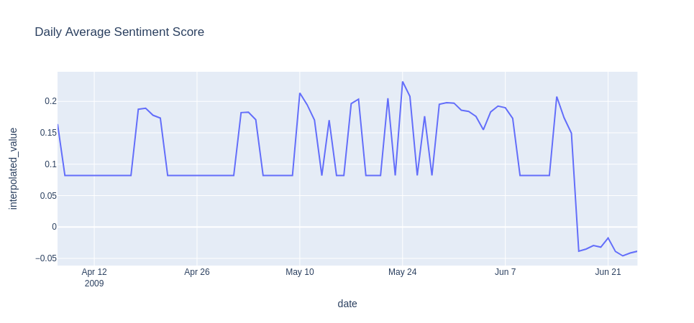
Fig. 1. Daily Average Sentiment Score before Lemmatization, Tokenization and Stop Word Removal
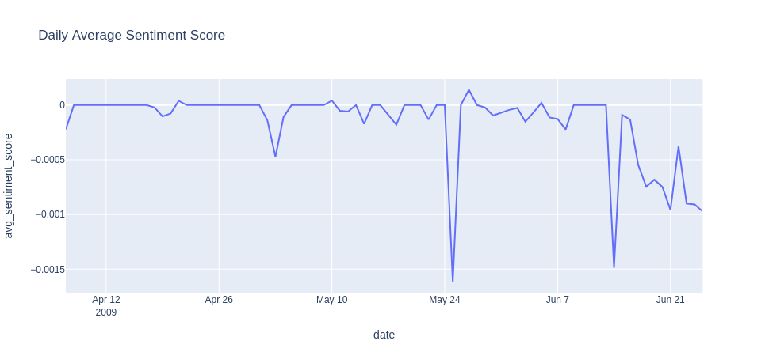
Fig. 2. Daily Average Sentiment Score after Lemmatization, Tokenization and Stop Word Removal

Interpolation
The script's primary focus is on the "avg_sentiment_score" column, in which missing values are carefully substituted with zeros. This is accomplished by employing the fillna method methodically, ensuring a consistent and controlled approach to dealing with missing data elements.

Interpolation Techniques
- Backward Fill: Retrospective interpolation is executed using the lag function, contributing to a holistic approach to data imputation.

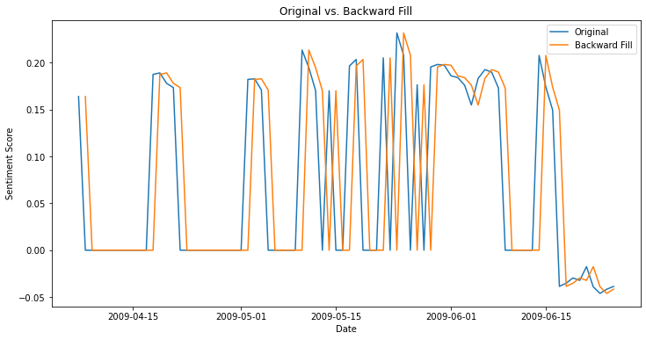
Fig. 3. Original vs. Backward Fill

- Linear Interpolation: Leveraging the lag function, the script implements linear imputation to bridge gaps between existing data points.

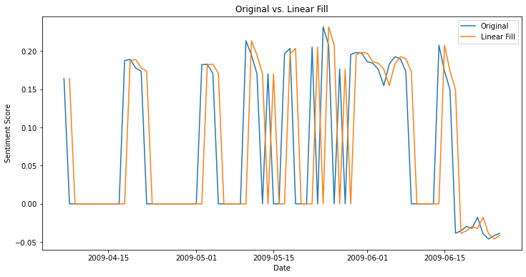
Fig. 4. Original vs. Linear Interpolation
- Quadratic Interpolation: A nuanced approach is taken, utilizing the coalesce function to bring a quadratic element to the interpolation process.

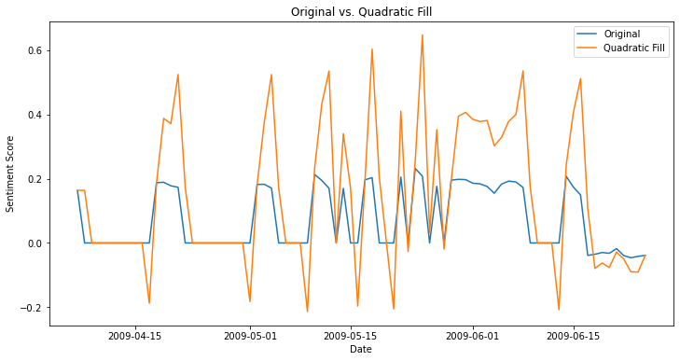
Fig. 5. Original vs. Quadratic Fill

- Mean of Nearest Neighbors: The mean of neighboring data points is calculated using lag and lead functions, introducing a contextual dimension to the imputation.

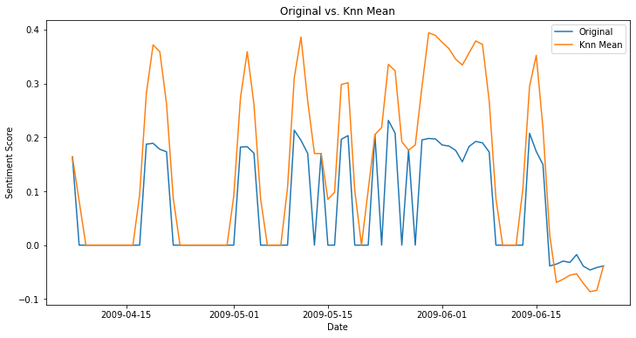
Fig. 6. Original vs. KNN Mean Fill

- Mean of Seasonal Counterparts: Incorporating a 7-day temporal shift, this method adds sophistication to the interpolation process, considering seasonal patterns in the data.

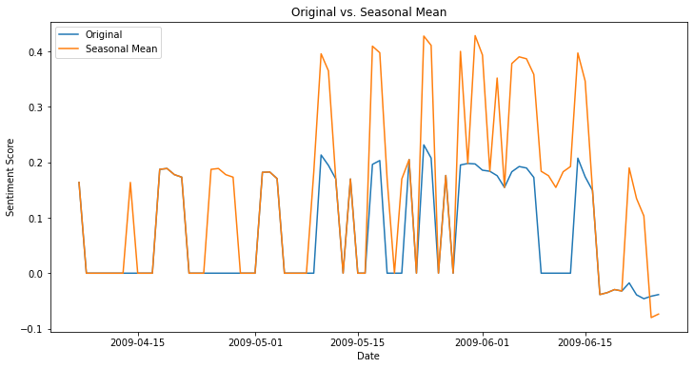
Fig. 7. Original vs. Seasonal Counterpart Fill

The line charts show that the usage of backward fill start interpolation, in which the dataset is retroactively filled from the end date to the past, deviates from our planned application, which is largely focused on forecasting future values. Furthermore, both the quadratic fill and KNN mean techniques cause a significant change in the inherent nature of the scores, which has the potential to negatively damage our forecast model. While seasonal counterpart interpolation appears to be a viable alternative to other methods, I recommend using linear interpolation in this case. This preference stems from its inherent property of establishing a straight line between two known points, making it easier to determine intermediate values along that line. As a result, in comparison to other interpolation approaches, this methodology has a considerably smaller influence on the character of the findings.

Time Series Analysis
AR with Random Forest Regressor were conducted for time series analysis due to its ability to handle non-linear relationships and capture complex patterns in the data. Its ensemble learning approach, combining multiple decision trees, provides robust predictions, making it suitable for diverse time series patterns (Liaw, 2002). SARIMA was selected due to its seasonal pattern capturing.

ADF and KPSS Test
Time series data frequently display temporal relationships and trends that might defy many statistical models' assumptions. As a result, before using time series analysis, Augmented Dickey Fuller (ADF) and Kwiatkowski-Phillips-Schmidt-Shin (KPSS) were performed to determine the data's stationarity. The ADF test assesses whether a unit root is present in a univariate time series, which is an indication of non-stationarity (Dickey, 1979). The ADF test's null hypothesis is that the time series has a unit root, implying non-stationarity. The ADF Statistic in the output is -3.71, and the related p-value is 0.003. Because the p-value is less than the significance level (usually 0.05), the null hypothesis is rejected. As a result, the time series seems to be stationary.

On the other hand, the KPSS test checks for stationarity around a deterministic trend (Kwiatkowski, 1992). The KPSS test's null hypothesis is that the series is stationary around a deterministic trend. The KPSS Statistic is 0.28, and the p-value is 0.1 in the result. If the p-value is greater than the significance level, the null hypothesis is not rejected, indicating that the series is stationary (Anon., 2023).

Detrend
Facilitating Analytical Processes: The application of detrending serves to enhance the analysis of time series data by simplifying the examination of its remaining components (Smith, 2010). By removing the trend, it is easier to focus on the cyclical and random changes, which may include useful insights into the dataset's short-term behavior. As it seems in the line chart the dataset values are going up with the time.

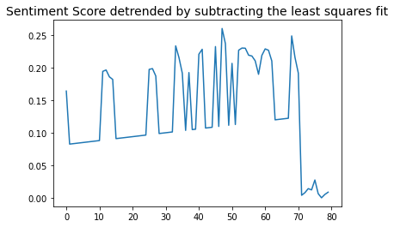
Fig. 8. Detrended Sentiment Score

Seasonality

Daily time series analysis was conducted due to the existence of several null values in the dataset, which necessitates the interpolation of these gaps. The basis for this analytical study is the possibility of improving the efficacy of time series forecasting. One might expect a refinement in predicting precision by strategically addressing and using the additional dataset produced by interpolation. The dataset augmentation is poised to significantly contribute to the model's training, providing a more comprehensive temporal representation and, as a result, improving the model's prognostic capabilities.

Auto Regressive Model

This method does a detailed time series analysis and predictions using firstly Auto Regressive (AR) modeling and after with Random Forest Regressor algorithm (Statsmodels Development Team, 2023). Data splitting, visual depiction of training and test sets, and feature engineering with lag variables ('lag1' and 'lag2') to capture temporal dependencies are all part of the process (Cryer, 2008).

The AR model, which was trained using the statsmodels library's Ordinary Least Squares (OLS) regression, predicts the future. Forecasting capabilities can be evaluated by visualizing expected values with actual data.

For optimal parameter selection, hyper parameter tuning combines the Random Forest Regressor with GridSearchCV and Leave-One-Out Cross-Validation (LOOCV). The optimized model is now trained, and predictions are shown for complete performance evaluation. The Mean Squared Error (MSE) is used in quantitative evaluation to calculate the squared difference between expected and actual values and it resulted .

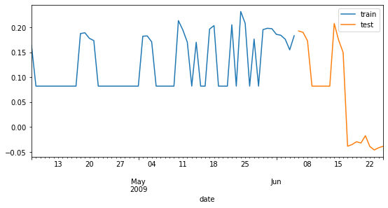
Fig. 9. Train and Test Data

OLS Regression Results
The model explains 14.8% of the variation in the 'interpolated_value,' as evidenced by the R-squared value of 0.148. This shows that the model's capacity to account for observed variance in the dependent variable is restricted.

The F-statistic of 4.775 with a p-value of 0.0122 indicates that the overall model is statistically significant. This implies that at least one of the predictors has a statistically significant effect on the dependent variable.

- The coefficient for 'lag1' is 0.3454, meaning that a one-unit increase in 'lag1' corresponds to a 0.3454-unit rise in the 'interpolated_value.'
- The coefficient for 'lag2' is 0.0884, however it is not statistically significant (p-value = 0.511), implying that it may have no effect.

Prediction of AR Model

The AR model's prediction efficiency is limited, as evidenced by its inability to capture observed patterns. As a result, the choice is made to use the Random Forest Regressor for more robust forecasting, predicting greater predictive performance and resolving the constraints of the AR model.

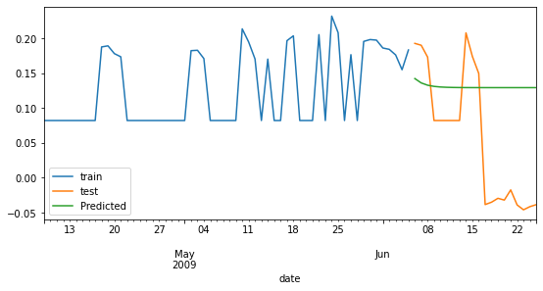
Fig. 10. Result of AR Model

AR Model with RandomForestRegressor
GridSearchCV will be used to determine optimum hyperparameters for the Random Forest Regressor method in order to improve forecasting accuracy. Following that, the AR model will be used in the analytical framework.
Best hyperparameters:
- n_estimator: 500
- max depth: 3
- Best MSE Score: 7.873256180015573e-08.

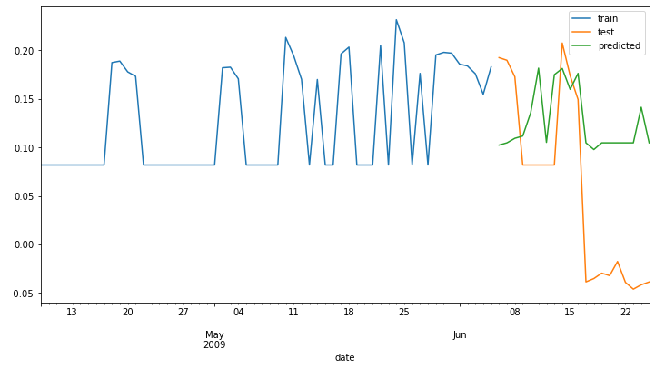
Fig. 11. Result of AR with RandomForestRegressor

The forecasting findings differ from the original dataset. Notably, a visible projection of an upward trend in scores is observed in the forecast's second peak, while accurately anticipating a subsequent decrease. The forecast, however, fails to accurately estimate the magnitudes of these observed values.

SARIMA Model
The results of attempts to anticipate using both the AR model and the Random Forest Regressor have been less than ideal. Notably, apparent trends within the dataset show a regular weekday drop and weekend ascension in scores. As a result, the Seasonal AutoRegressive Integrated Moving Average (SARIMA) model evolved in the pursuit of a more refined forecasting methodology.
- Seasonal Order = (1, 0, 1, 7)
- Seasonal Auto Regressive Order (p): The number of lag observations incorporated in the model is indicated by this parameter (1). It implies that the value of the time series at each period is influenced by its value at the same period the previous week in this context.
- Seasonal Difference Order (d): The seasonal differencing (0) indicates how many times the series is differenced during the seasonal period. No seasonal differencing is used in this scenario (d=0).
- Seasonal Moving Average Order (q): Parameter (1) represents the seasonal moving average component's order. It means that the mistake at each period is influenced by the error at the same period the week before.
- Seasonal Periodicity (S): The seasonal periodicity (7) is the number of time periods in a season. In this context, it suggests a weekly seasonality, considering the natural periodicity of days in a week. This choice has been made due to the distinctions between weekends and weekdays.

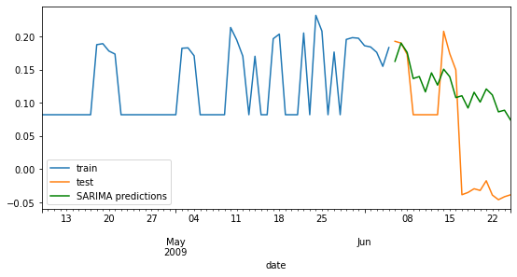
Fig. 11. Result of SARIMA Model

In the framework of the SARIMA model, the results show a greater degree of promise than previous attempts. While the initial forecast is somewhat inaccurate, it nevertheless produces better predictions than alternative models. The SARIMA model effectively predicts peak scores and accurately predicts downward trends. It is worth noting that, keeping with the underlying structure of forecasting models, projections for proximate temporal intervals tend to be more precise than those further into the future.

Conclusion
The tweet data underwent processing using PySpark, integrating sentiment analysis with the Vader Sentiment Intensity Analyzer. Two distinct sentiment analyses were undertaken, one conducted before lemmatization, tokenization, and stop word removal, and the other subsequent to these preprocessing steps. The superior efficacy of sentiment scores became evident, offering more comprehensive insights into the overall sentiment of the texts, particularly given the constraints of limited text data the results are visualized on a dashboard using the Dash library. Consequently, further analysis proceeded without lemmatization, tokenization, and stop word removal. Imputation of null-valued sentiment scores involved the application of five different methods, with linear interpolation selected for subsequent analysis. Consideration of Seasonal Counterpart Fill is recommended for further exploration, and alternative sentiment analyzers such as NLTK and TextBlob could be contemplated. While visualizing sentiment score polarity may enhance interpretability, the primary emphasis remains on forecasting.

MySQL database and Hive data warehousing were employed and subjected to YCSB benchmarking tests, resulting in technical issues and cProfile was preferred for performance measure. Performance testing using cProfile affirmed the superiority of the Hive data warehouse. For future analyses, the consideration of the Redis database management system is proposed due to its user nickname-based data storage system, which offers potential advantages for organizing social media data. The Redis exhibits support for a range of data structures such as strings, hashes, and sets, providing a notable degree of flexibility in organizing user nickname data efficiently. This versatility allows individuals to employ the Redis sets for the purpose of managing unique nicknames, or alternatively, to utilize hashes for the storage of supplementary user information linked to the respective nicknames. This adaptability in data structuring within the Redis contributes to an effective and tailored approach to handling user-related data in various applications (The Redis, 2023).

For time series analysis and prediction, this work used a careful two-step technique. The early Auto Regressive (AR) modeling, performed with the statsmodels library's Ordinary Least Squares (OLS) regression, had predictive ability but struggled to capture observable patterns. As a result, the Random Forest Regressor method was used in the study to provide more robust forecasting, overcoming the constraints of the AR model. The optimization procedure included tweaking hyper parameters with GridSearchCV and Leave-One-Out Cross-Validation (LOOCV). Despite the fact that the AR model only explained 14.8% of the variation in the 'interpolated_value,' the Random Forest demonstrated superior predictive performance. The study presented a Seasonal Auto Regressive Integrated Moving Average (SARIMA) model to address observed trends, with promising results in predicting peak scores and capturing downward trends. The seasonality is selected by the nature of the dataset. Future analyses could explore alternative models for comparative evaluation.

References
GitHub Kagan Timur: https://github.com/kgntmr/Project-Tweets/tree/main
A., B., 2017. Sentiment Analysis: Methods and Applications. Journal of Textual Analysis. s.l., s.n., pp. 123-145.
Anon., 2023. otext. [Online]
Available at: https://otexts.com/fpp2/stationarity.html
[Accessed 11 11 2023].
Armbrust, M. X. R. S. L. C. H. Y. L. D. B. J. K. .. &. Z. M., 2015. Spark SQL: Relational data processing in Spark. s.l., ACM SIGMOD, pp. 1383-1394.
Begg, C. T. &., 2014. Database Systems: A Practical Approach to Design, Implementation, and Management (6th ed.). s.l., Pearson.
Cooper B. F. Silberstein A. Tam, E. R. R. &. S. R., 2010. Benchmarking cloud serving systems with YCSB. s.l.:s.n.
Cryer, J. D. &. C. K.-S., 2008. Time Series Analysis: With Applications. s.l.:R. Springer.
De Mauro, A. G. M. &. G. M., 2015. What is Big Data? A Consensual Definition and a Review of Key Research Topics. AIP Conference Proceedings. Madrid, 4th International Conference on Integrated Information, pp. 97-104.
Dickey, D. A. &. F. W. A., 1979. Distribution of the estimators for autoregressive time series with a unit root. Journal of the American Statistical Association, pp. 427-431.
Documentation, P., 2023. PyMySQL Documentation. [Online]
Available at: https://pymysql.readthedocs.io/en/latest/
[Accessed 11 11 2023].
Du, X. H. C. &. H. K., 2012. MySQL and PostgreSQL: Database management for large-scale biomedical data. s.l., IEEE 8th International Conference on E-Science.
Hutto, C. J. &. G. E., 2014. Vader: A parsimonious rule-based model for sentiment analysis of social media text. s.l., Eighth International Conference on Weblogs and Social Media.
Kwiatkowski, D. P. P. C. S. P. &. S. Y., 1992. Testing the null hypothesis of stationarity against the alternative of a unit root. Journal of Econometrics, pp. 159-178.
Liaw, A. &. W., 2002. Classification and regression by randomForest.. s.l., R news.
Meng, X. B. J. Y. B. S. E. V. S. L. D. .. &. Z. M., 2016. Machine learning in Apache Spark. The Journal of Machine Learning Research. s.l., MLlib.
MySQL, 2023. MySQL Documentation. [Online]
Available at: https://dev.mysql.com/doc/
[Accessed 11 11 2023].
Redman, T., 1996. Data Quality for the Information Age. s.l., Artech House.
Smith, J. B. A. &. D. C., 2010. Time Series Analysis: Methods and Applications. s.l., Harvard University Press.
Statsmodels Development Team, 2023. Statsmodels: Econometric and statistical modeling with Python. [Online]
Available at: https://www.statsmodels.org/stable/index.html
The Redis, 2023. Redis Documentation. [Online]
Available at: https://redis.io/documentation
[Accessed 13 11 2023].
Thusoo, A. S. J. S. J. N. S. Z. C. P. A. S. .. &. M. R., 2010. Hive: A warehousing solution over a map-reduce framework. s.l., Proceedings of the VLDB Endowment.

